<!--This file created 2:29 PM 10/29/97 by Claris Home Page version 2.0-->2.1 Project
Numerical Slope Investigations

In each of the problems listed below, it is known that the slope m of the tangent line to the graph  at the fixed point 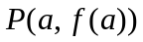 is either an integer or the reciprocal of a single-digit integer. Use this fact to determine m numerically by using a graphing facility (calculator or computer) with which you can "grab" the xy-coordinates of a selected point on the graph. Suppose you "zoom in" on the point P, and at the kth zoom record the coordinates 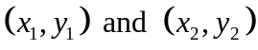 of two points located on either side of P. Then you can approximate the value of m by calculating the value of the difference quotient
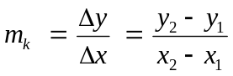.

After enough zooms, it should be clear what rational value the approximate slopes 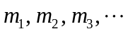 are approaching.

1.
2.
3. 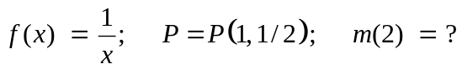
4. 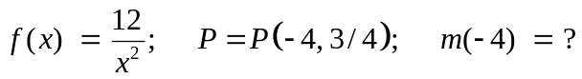
5.
6. 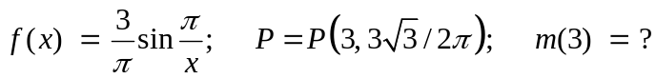

In the following sections we use the simple problem

to illustrate the use of graphing calculators and computer algebra systems to carry out numerical slope investigations as described above.

Using a Graphing Calculator
In the TI-83 calculator screens at the top of the next page we are tracing the curve 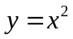 in the window (where the graph already looks sufficiently linear that our difference quotient approximation should be quite accurate).

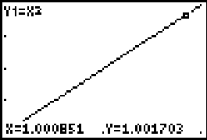
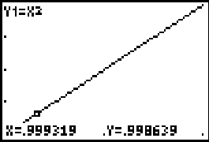

We see the points P₁(0.999319, 0.998639) and P₂(1.000851, 1.001703) to the left and right of the given point P(1, 1). The corresponding difference quotient approximating the slope m is

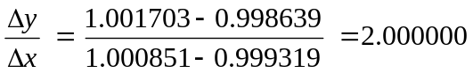

(accurate to 6 decimal places). We conclude that m = 2.

Using Maple

The command

plot(x^2, x=0.999..1.001, y=0.998..1.002);

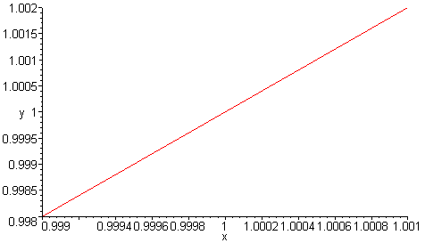

plots the curve with enough magnification that the graph already looks sufficiently linear that our difference quotient approximation should be quite accurate.

By examining this graph carefully, we pick out the points P₁(0.9992, 0.9984) and P₂(1.0008, 1.0016) to the left and right of the given point P(1, 1). (We have recorded the coordinates of P₁ and P₂ with the accuracy permitted by the tick marks on the axes in the figure.) The corresponding difference quotient approximating the slope m is

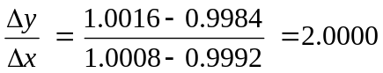

(accurate to 4 decimal places). We conclude that m = 2.

Using Mathematica

The command

Plot[{x^2},{x,0.999,1.001}]

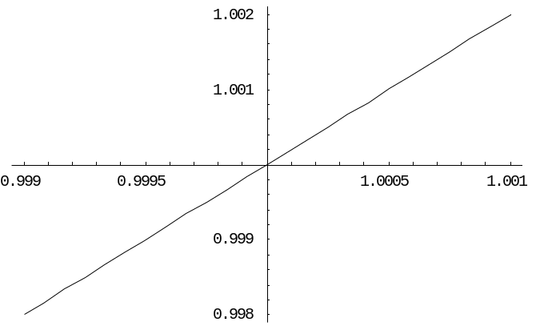

plots the curve with enough magnification that the graph already looks sufficiently linear that our difference quotient approximation should be quite accurate.

To grab coordinates on a Mathematica plot, we need only hold down the Control key (in the Windows version) and move the cursor to the desired point or points. The coordinates of the cursor position are displayed at the bottom of the screen. And if you click one or more times while still holding down the Control key, these coordinates can be copied and pasted into an input cell. With the graph above, this procedure gives the points

P1 = {0.999079, 0.998168}
P2 = {1.00091, 1.00183}

on the graph to the left and right of P(1, 1). The corresponding difference quotient 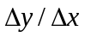 approximating the slope m is then calculated automatically by

m = (P2[[2]]-P1[[2]])/(P2[[1]]-P1[[1]])
2.
We conclude that m = 2.

Using MATLAB

The command

fplot('x.^2', [0.999 1.001 0.998 1.002])

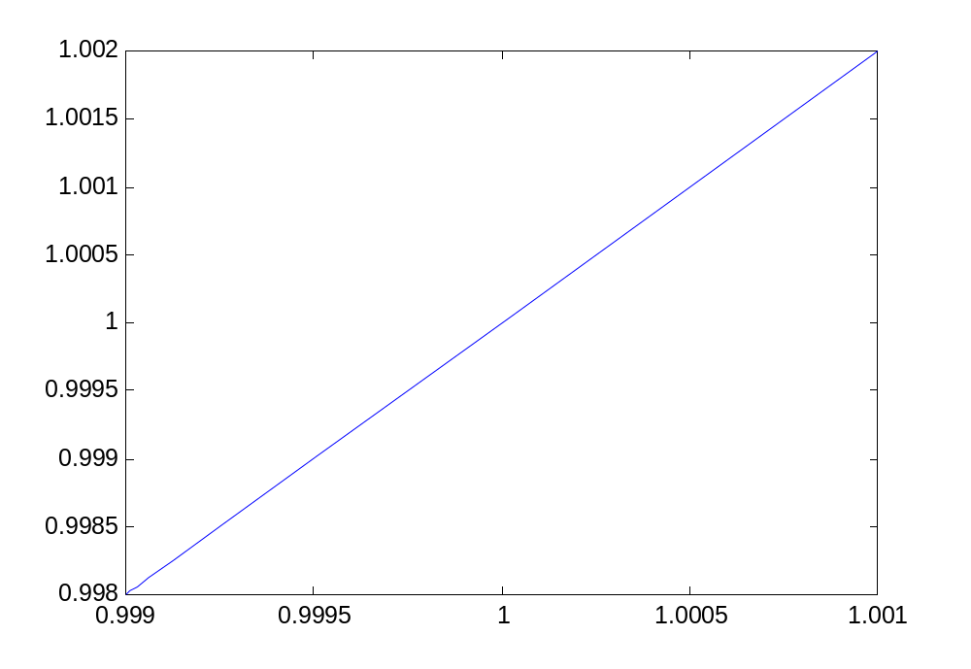

plots the curve with enough magnification that the graph already looks sufficiently linear that our difference quotient approximation should be quite accurate.

With MATLAB we can use the command ginput(N) to grab the coordinates of N points that we select on the curve by moving the crosshairs and mouse-clicking. Thus we get the x- and y-coordinates of two points on the left and right of P:

[x,y] = ginput(2)
x =
0.9991
1.0008
y =
0.9982
1.0017
The corresponding difference quotient approximating the slope m is then calculated automatically by

(y(2)-y(1))/(x(2)-x(1))
2.0001
We therefore conclude that the desired slope is m = 2.

